**🕹️ Steps to Share Your Game Internally using GitHub Pages**

1. Open your GitHub account in a browser, Log with your personal account.

1. **Create a new repository from new icon from home page**

Select yourself as the owner, name your repository, and add a description. Optionally, you can enable the Readme feature to generate a document that provides information about your project.

Select create repository

1. **Upload your game files**A screenshot of a computer

   AI-generated content may be incorrect.

To upload files, select the add file button and then choose upload files. A window will open allowing you to add all files saved in your local folder.

After uploading the files select commit changes to complete the process.

1. **Enable GitHub Pages**
   * Go to **Settings** → **Pages**.

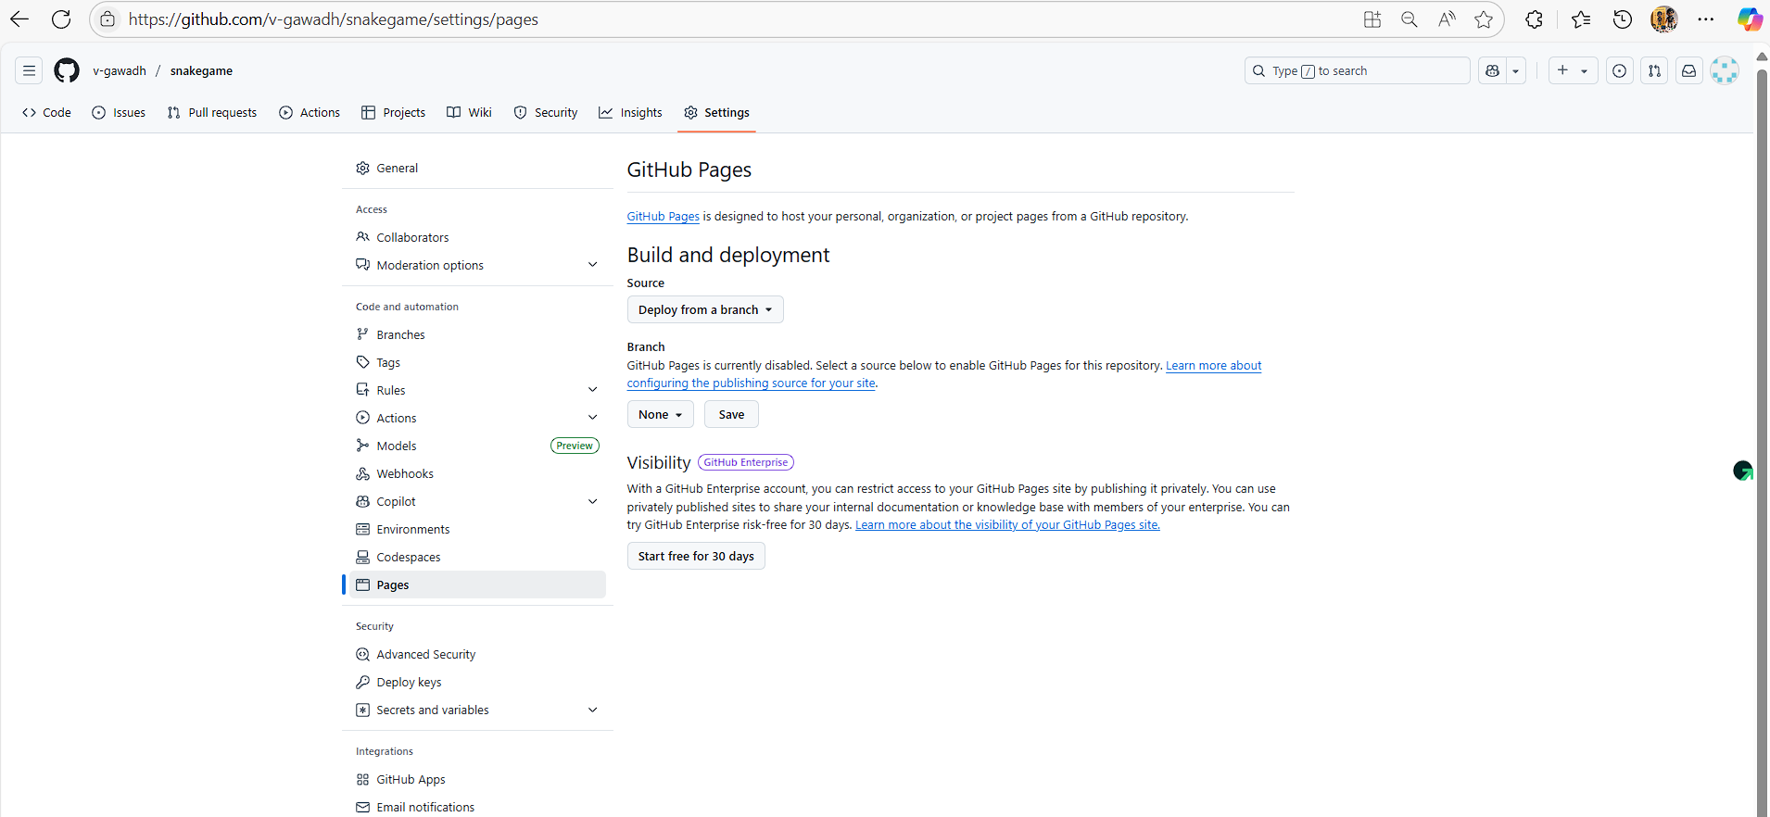

Under **Source**, choose the branch (e.g., main) and folder (/root) where your game files are saved

Save changes to generate a GitHub Pages URL.

**Wait for 2-3 min and refresh page multiple times, it will give you GitHub link which you can share.**

